黄昆半导体科学技术论坛
第 340 期 讲 座

报告题目: Condensed Matter Physics: What Happened Since Ashcroft/Mermin and Where Is It Going?

报告人: Prof. Kun Yang (杨昆教授)
（Department of Physics and National High Magnetic Field Laboratory, Florida State University, Tallahassee, Florida 32306）
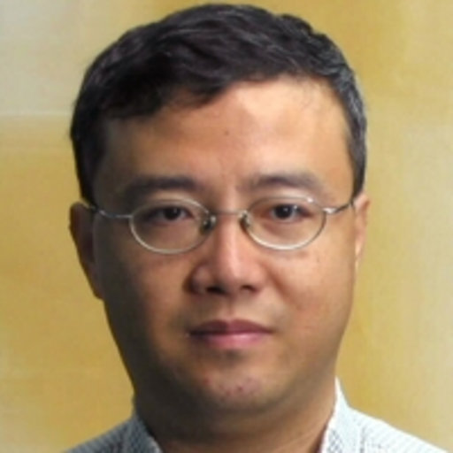
Abstract: The classic textbook by Ashcroft and Mermin, titled Solid State Physics, has dominated education of graduate students in the field of condensed matter physics since its publication in 1976. Tremendous progress has been made in this field over the past 40 years, and a modern textbook replacing this aging classic is in urgent need. In this talk I will report our attempt [1] to meet this need, and discuss the recent developments in condensed matter physics along the way, emphasizing its synergy with other fields.
[1] Modern Condensed Matter Physics, Steven M. Girvin and Kun Yang, ISBN: 9781107137394, Cambridge University Press, Cambridge (2019); http://admin.cambridge.org/pa/academic/subjects/physics/condensed-matter-physics-nanoscience-and-mesoscopic-physics/modern-condensed-matter-physics?format=HB.

Biography: 杨昆博士1985 年毕业于杭州二中并被保送复旦大学物理系，1989年本科毕业。随后经CUSPEA项目赴美，于1994年获印地安那大学博士学位。之后在普林斯顿大学及加州理工学院从事博士后研究工作。1999年起在佛罗里达州立大学任教，现担任McKenzie讲座教授。曾获得斯隆研究奖，海外华人物理学会青年研究奖，佛罗里达州立大学杰出科研教授奖等荣誉，并当选美国物理学会和美国科学促进会会士。曾兼任浙江大学光彪特聘教授和清华大学长江讲座教授，及中科院海外评审专家。

时间: 2018年5月24日(星期五) 上午10：00
地点: 中国科学院半导体研究所2号科研楼303A
联系人: 尚雅轩 82304453

