黄昆半导体科学技术论坛

**第326期讲座**

报告题目: Strategies toward High Efficiency Organic and Perovskite Solar cells

**报告人：Yang Yang** (Professor, Department of Materials Science and Engineering and California NanoSystems Institute, University of California, Los Angeles, California 90095, United States)

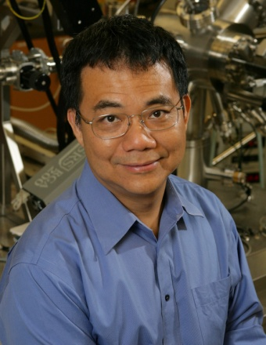**摘要：**In this presentation, I will firstly introduce the basic principal of photovoltaic (PV) materials and devices. Once the fundamental aspects have been laid out, I will follow with a detail discussion of organic photovoltaics (OPV) and perovskite (PVSK) PV technologies. OPV technology, utilized organic and polymer materials as the active elements, which has emerged as one of the promising photovoltaic technologies. Very recently, we obtained very high performance single-junction OPV by the synthesis of new infrared absorbing non-fullerene acceptors. These single-junction devices were certified by National Renewable Energy Laboratory (NREL), and a new record PCE of 12.6% PCE was achieved. On the other hand, perovskite solar cell is another major research in my group. In this presentation, I will report our recent understanding on methods for manipulation of the defects in perovskite solar cells. The inevitable defects at GBs were effectively passivated by additives. As a result, the PCE exceeding 21% was achieved for a planar heterojunction perovskite solar cell. Thanks to the passivated GBs, the device demonstrated significantly enhanced stability. I will also report our progresses on perovskite tandem solar cells. A high performance perovskite tandem solar cell was achieved via engineering of the interconnecting junction, where certified power conversion efficiency over 22% was demonstrated.

**简历：**杨阳教授本科毕业于台湾成功大学（1982年），硕士和博士毕业于美国马萨诸塞大学Lowell分校 （1988和1992年），1992年至1996年在美国UNIAX公司（现为杜邦显示）担任研究科学家。杨教授于1997年加入美国加州大学洛杉矶分校（UCLA）材料科学与工程系，现任UCLA卡罗尔和劳伦斯·Tannas Jr.讲座教授。杨教授的主要研究方向包括有机电子学、有机/无机界面工程以及太阳能电池和发光二极管等光电子器件。目前，他已在国际知名刊物上发表三百余篇论著（包括书籍章节），获得32项授权专利，并在国际重要学术大会上做大会报告和邀请报告120余次。他的H因子在2018年达到141（被引用近90,000次）。杨教授是美国材料研究学会（MRS）、英国皇家化学学会（RSC）、美国物理学会（APS）以及国际光学工程学会（SPIE）的fellow。

**时间: 2018年7月27日 (星期五) 上午10:00**

**地点: 中国科学院半导体研究所3号楼320会议室**

**联系人:尚雅轩 82304453**