黄昆半导体科学技术论坛
第 315 期 讲 座
报告题目: Novel Approach to Grow High-Quality and Large-size Freestanding AlN Single Crystals by PVT Method

报告人: Professor Liang Wu
（State Key Laboratory of Advanced Special Steel, School of Materials Science and Engineering, Shanghai University）

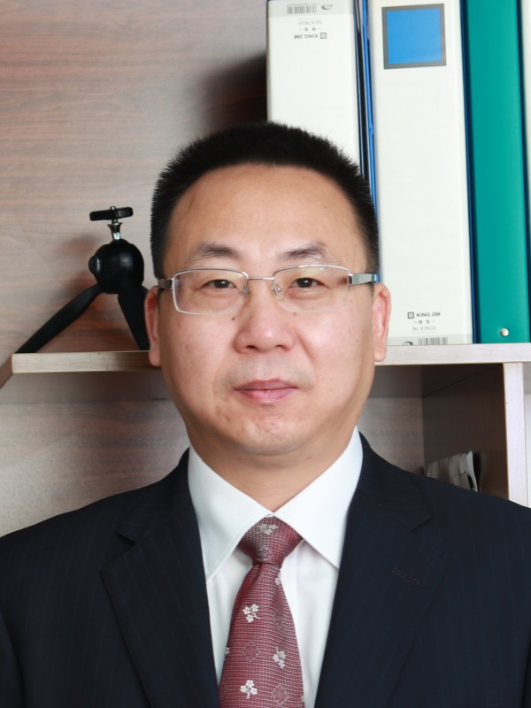
Abstract: Due to its ultra-wide bandgap (6.2eV), similar thermal expansion coefficient and chemical properties as compared with GaN and AlGaN, bulk single-crystalline aluminum nitride (AlN) is the most promising substrate for deep-UV optoelectronic devices. However, the huge potential of this substrate is limited by the current lack of sufficiently large and high-quality single crystals. In this talk, we presented a novel spontaneous approach to grow freestanding AlN crystals by an in-house designed 3-inch PVT sublimation reactor. The growth results showed that Freestanding AlN single crystals can be grown on the pre-sintered AlN powder source by accurately controlling the temperature profile in the growth chamber. The largest AlN single crystal for a 100h holding time under specified growth conditions reached 10mm*8mm*12mm, while typical diameters were between 7mm-8mm. The full-width at half-maximum (FDHM) of chosen grown crystal measured by Raman spectroscopy and HDXRD was 5.5/cm and 93.6 arcsec, respectively. The etch pit density (EPD) revealed by SEM after wet chemical etching in molten eutectic KOH/NaOH arranged 10²–7.5*10⁵ /cm² . These results showed that high-quality and large-size freestanding AlN single crystals can be grown by this novel approach. The obtained AlN single crystals can be cut into wafers ideally suited as seeds for subsequent homoepitaxial AlN crystal growth. We expect inch-size AlN single crystal could be achievable in the near further based on high-quality seeds and homoepitaxil growth iteratively.

Biography: Professor Liang Wu has around 20 years of research and development experience on various crystal growth processes and material engineering for semiconductor, solar and LED applications, including crystal growth equipment and hotzone design, modeling & optimization and material characterization. His current research interest is mainly focused on bulk AlN crystal growth for UV applications. Dr. Liang Wu received his Ph.D, master and bachelor degree from University of Louvain, Tsinghua University and Dalian University of Technology, respectively. He joined Shanghai University in 2014 as an “Oriential scholar” professor. Previously, he held various R&D and management positions at Intel, FEMAGSoft SA (Belgium), and GCL Energy Holding Limited. He applied around 30 patents (including PCT, mainly on AlN bulk crystal growth), and authored one book published in Germany. He contributed more than 60 journal/conference papers and invited talks. He was invited plenary keynote speaker of PV Japan and invited speaker of several international conferences such as ICCGE, IWMCG, Semi China, Semi Japan, Semi Taiwan, SNEC, ChinaLED, PV Summit etc.. He is a guest editor and invited reviewer of Journal of Crystal Growth, and scientific committee member of SEMIChina since 2011.

时间: 2018年4月13日(星期五) 上午09：30
地点: 中国科学院半导体研究所学术会议中心
联系人: 徐艳坤 82304453

