黄昆半导体科学技术论坛

**第333期讲座**

**报告题目:** **Van der Waals Semiconductor Monolayers and Heterostructures as New Photonic Materials**

**报告人:** **Prof. Xiaoqin (Elaine) LI（Professor of Physics, University of Texas-Austin, USA）**

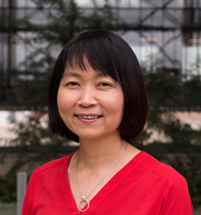**Abstract**: Atomically thin semiconductor monolayers or heterostructures have emerged as a promising photonic material platform. A few characteristics make these two-dimensional quantum materials particular attractive. Following a brief summary of fundamental properties of excitons and valley index, I will discuss two examples of our recent work in this area: (i) how to control valley polarized excitons using a metasurface and (ii) how interlayer excitons confined in the moiré potential of a vertical heterostructure may act as an array of quantum emitters.

**Biography:** Prof.Xiaoqin Li received her B.S. in physics from Beijing Normal University in 1997 and her PhD in 2003 from University of Michigan. She was a postdoc fellow at JILA, Colorado from 2003-2006. She started as an assistant professor at UT-Austin in 2007. Prof. Li has received a number of awards including the Presidential Early Career Award for Scientists and Engineers in the U. S. and a Sloan Fellowship. She held a Humboldt Fellowship in 2015-2016 while she visited the Technical University of Berlin. She was elected a fellow of the American Physics Society in 2015.

**时 间: 2018年12月28日(星期五) 上午10:00**

**地 点: 中科院半导体研究所 2号楼303A**

**联系人: 尚雅轩 82304453**