黄昆半导体科学技术论坛

第328期讲座
报告题目: Spin-Orbit Torques: Discoveries, Advances and Possibilities

报告人: Prof. Robert Buhrman (Applied Physics, Cornell University, USA)

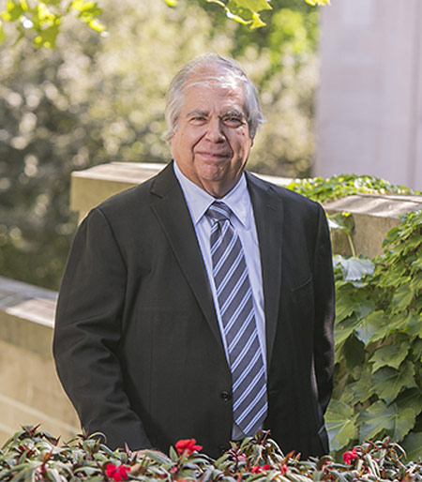
Abstract: The discoveries early in this decade establishing that robust spin-orbit torques (SOT) can be exerted on the magnetic structure of a ferromagnetic thin film by charge flow in a thin film bilayer consisting of that ferromagnet and a heavy metal layer opened up a broad new exciting area of nanomagnetism research for fundamental studies and potential spintronics applications. Since then there have been many highly notable developments, including: (1) major advances in the understanding of the different possible origins of SOT and their range of characteristics; (2) the identification of new classes of materials that can provide strong spin currents and different types of SOT; (3) the demonstration of new concepts and approaches to effectively utilize SOT in a variety of ways for efficiently manipulating magnetism at the nanoscale; and (4) marked progress in both understanding and controlling the physics that degrade spin currents in heterostructures, and in enhancing the strength of SOT of conventional heavy metal systems through materials engineering. In this presentation I will focus largely on a selection of some of more recent developments in the first and last of these topic areas, particularly those that arguably show promise for possibly enabling a successful SOT technology in the relatively near term. Then in the last part of my presentation I will discuss some recent progress that has been made towards the effective demonstration of fast, reliable, low pulse current SOT switching of three terminal magnetic tunnel junction devices.

报告人简介：ROBERT BUHRMAN is the J.E. Sweet Memorial Professor in the School of Applied and Engineering Physics at Cornell University, where he previously also served in a number of academic and research leadership positions. Throughout his career Buhrman’s research activities have been in the area of electronic materials and devices, within what is now known as nanoscale science and engineering. His current research focus, beginning about twenty years ago, is on nanomagnetic materials and spintronics. Among the earlier contributions of Buhrman and his collaborators in this area was the use of Andreev reflection spectroscopy to determine the spin polarization of currents at ferromagnetic nanocontacts, initial demonstrations of reversible spin transfer torque switching, first in magnetic spin valve nanopillars and then in magnetic tunnel junctions, followed by the quantitative determination of spin transfer torques, and of dynamic spin torque excitation effects in spin valves, magnetic tunnel junctions and of vortices in magnetic nanostructures. More recently, Buhrman and his teammates established the existence of a giant spin Hall effect in Pt, beta-Ta and beta-W thin films, and demonstrated its effectiveness for applications in novel 3-terminal spin-orbit torque devices. Currently Buhrman and his Cornell colleagues are contributing to the worldwide effort that is seeking to better understand, control and enhance spin torques arising from spin-orbit interactions, and to advance their potential for technology applications.

时间: 2018年10月10日(星期三) 下午3点
地点: 中国科学院半导体研究所学术会议中心
联系人: 尚雅轩 82304453

