黄昆半导体科学技术论坛

第329期讲座
报告题目: 1D van der Waals materials: Selenium and Tellurium

报告人: Prof. Peide D. Ye (School of Electrical and Computer Engineering, Purdue University, USA)
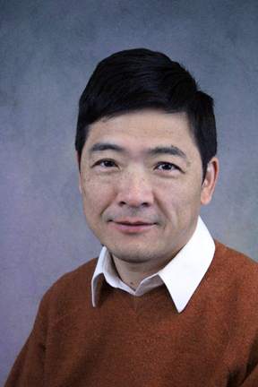
Abstract: Selenium and Tellurium are two special elemental materials which are 1D helical atomic structures and formed by van der Waals force between helical atomic chains. In this talk, we will report on the fundamental studies of these two new nano-materials at atomic scale in terms of their electrical, optical, thermal and mechanical properties [1,2]. The helical atomic structure offers strong anisotropic properties of these 1D van der Waals materials. The band-structures of the materials themselves also offer some excellent materials properties such as highest Seebeck coefficient for selenium and high carrier mobility of 700-800 cm2/Vs for tellurium with demonstrated field-effect transistor drain current exceeding 1 A/mm [3] and the first time observation of quantum Hall effect in tellurium [4]. The work is in close collaborations with Prof. Wenzhuo Wu at Purdue University.

[1] Y. Du et al., Nano Letters, 2017, 17, 3965-3973.
[2] J.-K. Qin et al., ACS Nano, 2017, 11, 10222-10229.
[3] Y. Wang et al., Nature Electronics, 2018, 1, 228-236.
[4] G. Qiu et al., Nano Letters, 2018, 18, 5760-5767.

报告人简介：Dr. Peide Ye is Richard J. and Mary Jo Schwartz Professor of Electrical and Computer Engineering at Purdue University in USA. He received BS from Fudan University, Shanghai, China, in 1988 and Ph.D. from Max-Planck-Institute of Solid State Research, Stuttgart, Germany, in 1996. Before joining Purdue faculty in 2005, he worked for NTT Basic Research Laboratory, NHMFL/Princeton University, and Bell Labs/Lucent Technologies/Agere Systems. His current research work is focused on atomic layer deposition technology and its device integration on novel channel materials including III-V, Ge, 2D materials and complex oxides. He authored and co-authored more than 200 peer reviewed articles and 350 conference presentations including many invited, keynote and plenary talks. He also served as chairmen and program committee members on top international conferences and symposia. He received IBM Faculty Award, Sigma Xi Research Award, and Arden Bement Jr. Award. He is a Fellow of IEEE and APS (American Physical Society).

时间: 2018年11月7日(星期三) 下午3：00
地点: 中国科学院半导体2号楼303A
联系人: 尚雅轩 82304453

